

**COMP3045 Information Visualization Project Coursework 2**

|  |  |
| --- | --- |
| **Name** | **Student ID** |
| Christopher Lychealdo | 20121244 |
| Loh Jin Xian | 18816763 |
| Tay Jen Wen | 18814558 |
| Yap Cheng Yee | 18816759 |

**Lecturer** **:** Dr. Marina Ng

**1.0 Purpose of the Visualization System**

Recently there has been an alarming trend in the rate of worldwide obesity, For the majority of countries, the average BMI has only been steadily increasing since the 1970s and the rate of obesity has doubled between the years of 1980 and 2008. [1]. This is a major area of concern because currently, the number of adults estimated to be obese is 2.1 billion people! Out of this number, there are 2.8 million people that die each year due to complications related to obesity or being overweight.

Obesity has a myriad of adverse effects on the body such as stroke, diabetes, coronary diseases and even cancer to name a few. To raise awareness of this mounting problem, our project focuses on the trend of obesity, as well as some other factors contributing to obesity.

The visualization system created in this project will be useful to several parties, with the first being nutritionists. Using the infographics, they will be able to give better advice to patients and also be able to show them in a clearer way of how obesity is harmful. The visualization is also useful for health enthusiasts and other bodies that promote healthy living. With the visualizations, they will be able to better raise awareness amongst the public regarding obesity. as infographics are more generally attractive than just texts or images. [2]

There are 3 main datasets used in the visualization. The first dataset is the average daily intake of fats and calories of each country alongside with recommended daily intake of both fats and calories. The second dataset is the exercise rate, it shows the number of people that have sufficient exercise for every country. The third and the last dataset is the prevalence of obesity, which shows the average BMI values of each country over a period of time.

**2.0 Analysis of Data**

By having an infographic to visualize the data, the reasons why people are getting more obese are becoming more apparent, especially Malaysians. For example, based on figure 1 in section 3.0, it is clearly indicated that Malaysia has one of the highest fats intakes when compared to other countries. Arguments can be made where a country like the United States and the United Kingdom has even higher fat intakes but do keep in mind that westerners also have a larger boy size when compared to Malaysians. Therefore, it is more appropriate to compare Malaysians with people from countries like Thailand and Cambodia, which without a doubt are not as obese as Malaysians, supporting the argument that high fat intake in relation to body size is linearly proportional.

However, obesity is never caused by just one factor. It is caused by the combination of different factors adding up to the formation of an obese person. The most common causes are eating too much and moving too little [3]. To keep functioning, human bodies need to use energy, which comes from calories that enters the body through food and drink. Calories are then converted to energy or stored as fat, which will remain inside the body, unless it is used up or calorie intake is reduced, forcing the body to draw on the reserves for energy [4].

When a person has high fat intake or calories, it is possible to be not obese if he or she is also a relatively active person in terms of sports or work. By being active throughout the day, it will create a phenomenon known as a caloric deficit, which is a shortage in the number of calories consumed relative to the number of calories required for maintenance of current body weight. Based in figure 3, most Malaysians don’t have an adequate amount of exercise yet consumed high amount of calories, which will cause caloric surplus instead. A caloric surplus is a state in which you eat more calories than you burn.

To simplify the findings, a person that takes in high fat intake and calories than the optimum amount that the body needs is known as caloric surplus.

**3.0 Design Implications**

**3.1 Initial proposed design**

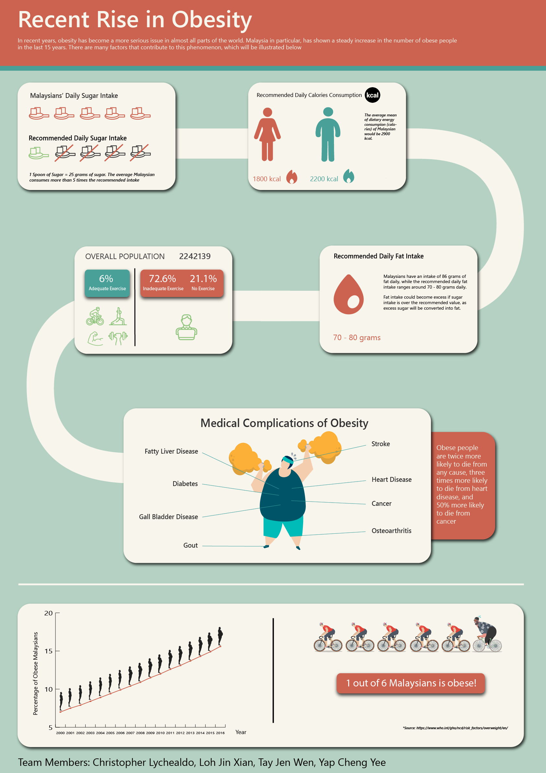

***Figure 1:*** *Initial design of website and information visualization*

The initial proposed design for the website and information visualization would be a website which comprises of different graphical design and facts which portraits the message needed to be conveyed for the user regarding on the rise in obesity among Malaysians.

The message was intended to be shown in a storytelling-based website, where the users will be shown visualizations on sugar, fat, and calorie intake, and exercise data. The last part shows the results and complications that might happen to obese people. This mimics the curved line showed in the poster, which connects one visualization after another, and ends with the facts on obesity.

However, based on the feedback from the presentation, is it proposed and suggested that the primary focus of the website should be placed on the information visualizations instead of the pieces of facts and design of the website.

**3.2 Major design concepts implemented**

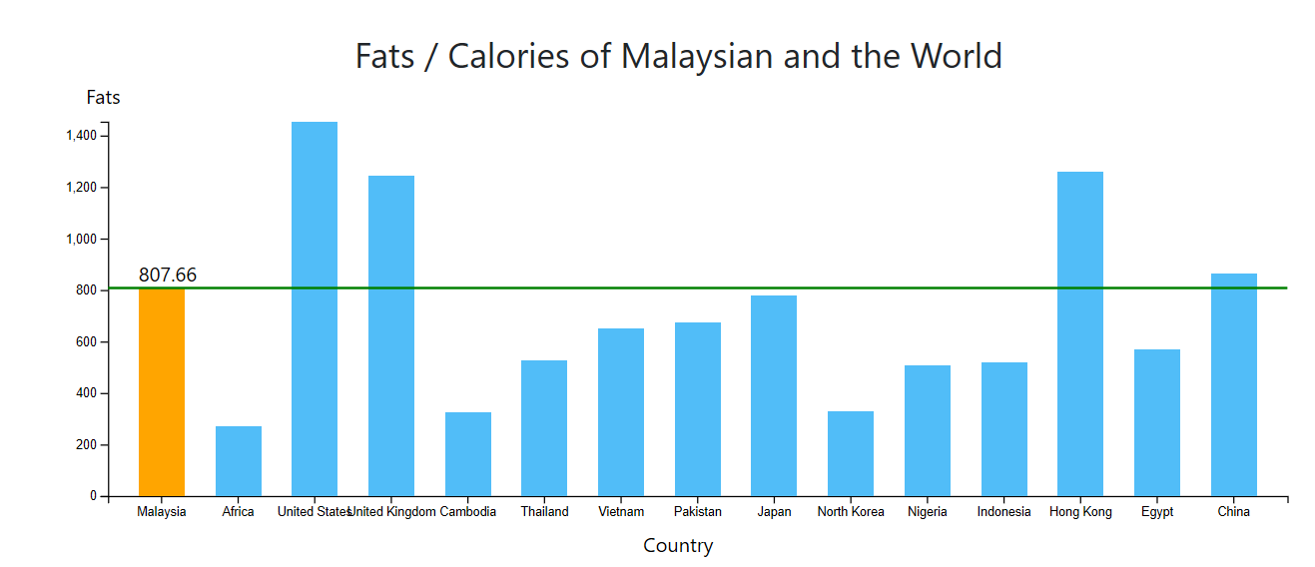

***Figure 2:*** *Barchart on fats intake of different countries*

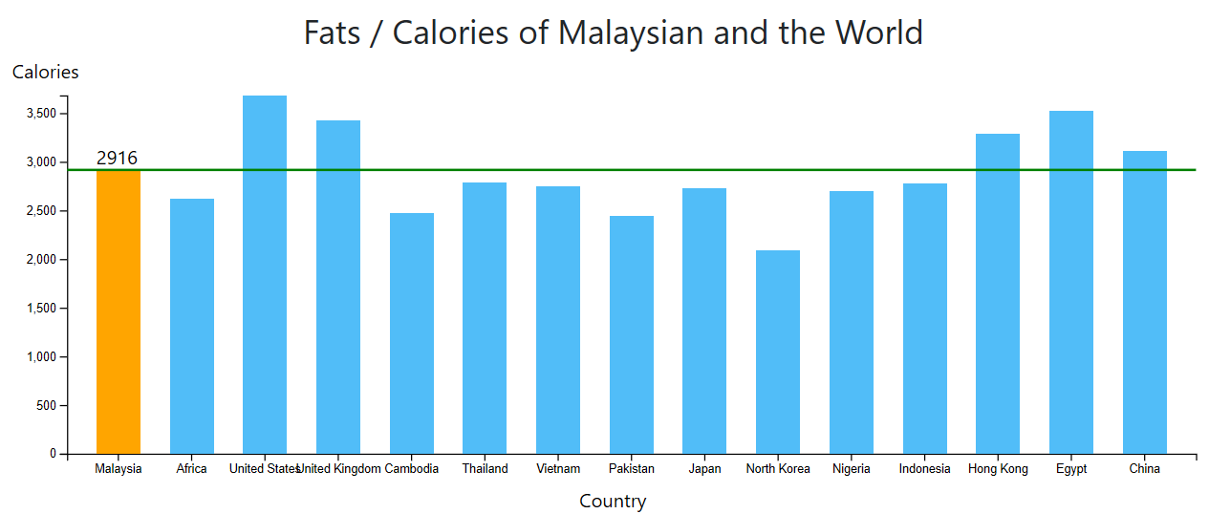

***Figure 3:*** *Barchart on calories intake of different countries*

Through the feedbacks from the presentation and demonstration, several major design concepts has been selected in order to improvise the proposed prototype of the design of the website and information visualization. A bar chart (Figure 2 and Figure 3) was used to show the different fats and calories intake of Malaysian on a daily basis as compared to the rest of the population of the world. The bar chart is able to display multiple countries and shows the differences between each country by comparing the height of each bar. The purpose of changing the colour of the selected bars is to indicate the specific bar of interest as compared to the other countries and a line was drawn across the other bar so that users are able to immediately compare the number of countries which are having a higher intake of fats and calories. A text was also appended at the top of each bar to indicate the precise values and provide more details and insight regarding each different intakes.

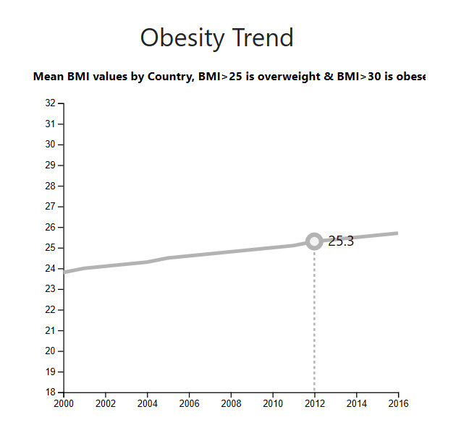

***Figure 4:*** *Line graph showing the obesity trend of different countries over the years*

A line graph (Figure 4) was used to show the mean BMI values of different countries over the years as using a line graph we could immediately determine a trend whether it is increasing or decreasing. The reason why a line graph was used for the obesity trend over a bar chart is due to the involvement of years as line graphs are exceptionally useful to show changes over time. A circle was appended along with a text is to show the precise BMI value of the year hovered over the line of the specific country to provide more details to the user. A dotted line was also shown to show the year users are currently at to provide more clarity as not every year is shown in the axis.

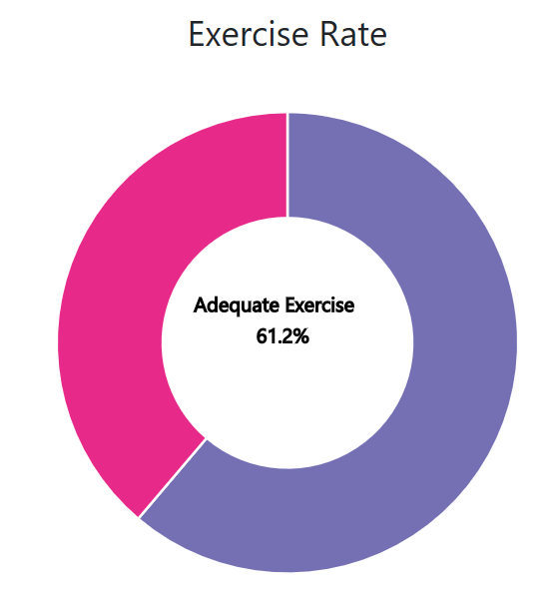

***Figure 5:*** *Pie chart showing the exercise rate of different countries*

A pie chart (Figure 5) was created to show the exercise rate of different countries as pie charts are useful to show percentages and to compare parts of a whole which in this case would be the inadequate and adequate exercise percentage. Using a pie chart, users are also able to immediately determine the proportion of the total quantity using the size of each pie and to summarize the whole dataset in a visual form.

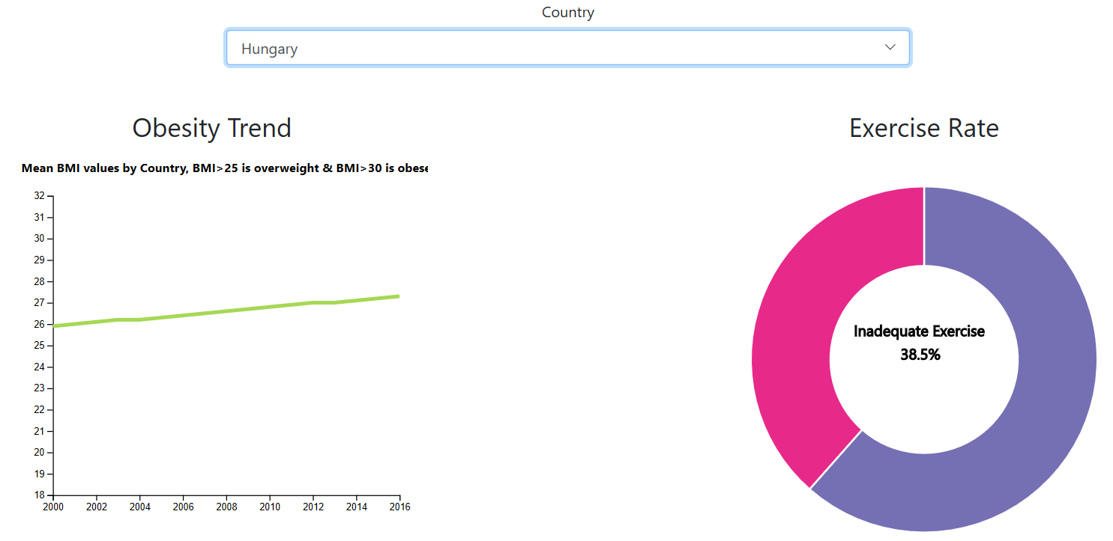

***Figure 6:*** *Dropdown to select a specific country to display the obesity trend and exercise rate*

Finally, a drop-down button (Figure 6) was created in order to connect both the line graph and pie chart by selecting one country. This would allow users to compare the obesity trend of the selected country along with its’ exercise rate without the need of selecting it twice. It would also show the correlation between obesity and exercise.

**4.0 References**

[1] Mean Body Mass Index (BMI). (2017, January 10). Retrieved from https://www.who.int/gho/ncd/risk_factors/bmi_text/en/

[2] Krum, R. (2014). *Cool infographics: Effective communication with data visualization and design*. Indianapolis: J. Wiley.

[3] NHS. (2016). Obesity Causes. Retrieved from <https://www.nhs.uk/conditions/obesity/causes/>

[4] Mayo Clinic Staff. (2018). Counting calories: Get back to weight-loss basics. Retrieved from <https://www.mayoclinic.org/healthy-lifestyle/weight-loss/in-depth/calories/art-20048065>